<https://www.cambly.com/en/student/courses/62cdf57ec3dbcad11563a640/62cdfa909459c8b55c119990>

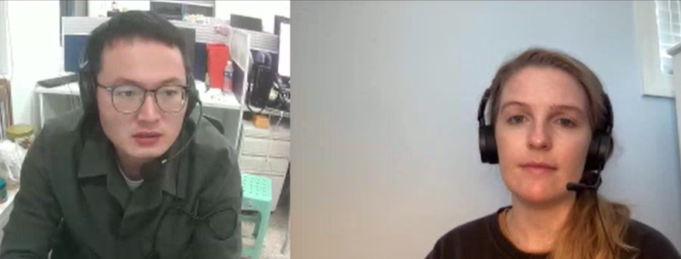

|  |  |  |
| --- | --- | --- |
| To figure out | Phrasal  ˈfreɪzl/ 短语 | To think or talk about something until you understand it |
| Big picture | Idiom  /ˈɪdiəm/ | The situation as a whole |
| To be/get on the same page |  | When people agree about what they are trying to do |
| Timeline |  | A plan that shows how long something will take or when things will happen |
| Long shot | /ʃɒt/ | Something you try although it is unlikely to be successful  胜率很小的选手；成功几率小的尝试；风险大的赌注 |
| Extension |  | An increase in the period of time before something is due |
| In charge of | Phrasal  Verb | In control or have overall responsibility |
| Cut corners | Idiom | To do something in the easiest, cheapest or quickest way, often by ignoring rules or leaving something out |
| Report to | Phrasal | To tell a manager or someone above you at work what you have done |
| Standards | Idiom | A level of quality, especially one that people think is acceptable |
| Take the lead | Idiom | To take responsibility for handling (or dealing with) a task |
| Quality control | Noun | The practice of checking that the work completed is good enough |

